**VENTURING CROWDFUNDING USING SMART CONTRACTS**

**IN BLOCKCHAIN**

**INTRODUCTION**

Crowd funding is a way to raise money from a large number of individual investors or companies. In this, investors can contribute to any project they are interested in and can gain the profit if that project gets successful. Now a days, many crowd funding platforms already exist and they take huge chunk of money from investors and contributes and leave them with empty promises. Crowd funding using block chain changes the traditional way to deal with business funding. Generally, when people need to raise a cash to begin a business, they have to design strategy, statistical surveying, and models, and afterward present the thoughts around to attract people or organizations. These subsidizing sources included banks, angel investors, venture capital firms. The present day crowd funding model depends on three kinds of on-screen characters: the task initiator who proposes the thought or venture to be funded, people or investors who invests in the thought, and a platform which puts these two characters together to make the venture successful. It is used to finance a wide scope of start-ups, pioneering ideas, for example, innovative activities, medical advances, travel and social business enterprise ventures.

**PROBLEM DEFINITION**

Using crowd funding, people can put resources into pioneering businesses through a middle medium or platform. The issue with the current crowd funding technique is that, third party medium don’t give the assurance of the money investor contributed for the project and investor don’t have control over the cash they contributed.

**PROPOSED SYSTEM**

The proposed system aims to leverage blockchain technology to enhance and streamline the crowdfunding process **.** envisions a more transparent, secure, and efficient crowdfunding platform, addressing the shortcomings of traditional models. By incorporating blockchain and smart contracts, the system aims to revolutionize the way projects are funded, fostering a global and inclusive crowdfunding ecosystem.

**OBJECTIVES**

* The main objectives is venturing crowd funding using smart contracts in block chain.

**BASIC FUNCTIONALITIES OF THE PROJECT**

1. **ADMIN**
2. Login
3. View user
4. Add donation request
5. View donation request
6. View user donation
7. View complaint and send reply
8. Change password
9. **USER**
10. Registration
11. Login
12. View donation request
13. Add donation (using block chain)
14. View previous donation
15. Send complaint and view reply

# C.ORGANIZATION

1. Registration
2. Login
3. View profile
4. Edit profile
5. Add change request to Blockchain
6. View donation details from user
7. Frond expenditure upload (IPFS) N/W storage highly secured platform
8. Excess amount equally return
9. Change password

**FUNCTIONAL REQUIREMENTS**

This section specifies all the fundamental action of the software system.

Class 1: ADMIN

Functional requirements 1.1

Title :View users

Description: Admin can view users

Functional requirements 1.2

Title :Donation request Management

Description: Admin can add/view donation request

Functional requirements 1.3

Title :View user Donation

Description: Admin can view user donation

Functional requirements 1.4

Title :view complaint and send reply

Description: Admin can view user complaints and add corresponding reply

to the system

Class 2: USER

Functional requirements 1.1

Title :Donation request

Description: User can view donation request

Functional requirements 1.2

Title : Add Donation

Description: User can add donation using block chain

Functional requirements 1.3

Title :View previous Donation

Description: usercan view previous donation

Functional requirements 1.4

Title :complaint

Description: usercan send complaints and view reply

Class 3: ORGANIZATION

Functional requirements 1.1

Title : Add Change request

Description: organizer can add change request to blockchain

Functional requirements 1.2

Title : Donation details

Description: Organizer can view donation details from user

Functional requirements 1.3

Title :Upload IPFS

Description: Organizer can frond expenditure upload (IPFS) N/W storage highly secured platform

Functional requirements 1.4

Title :Excess amount equality

Description: Organizer can excess amount equality return

**NON FUNCTIONAL REQUIREMENTS**

• Error handling:

The system shall handle expected and non-expected errors in a way that prevent loss in information.

• Performance Requirements

Speed of the system is an important constraint.

• Safety Requirements

System use shall not cause any harm to human users

• Security Requirements

• System will use secured database.

• The system shall permit only administrator/owner to modify the contents.

**ARCHITECTURE DIAGRAM**

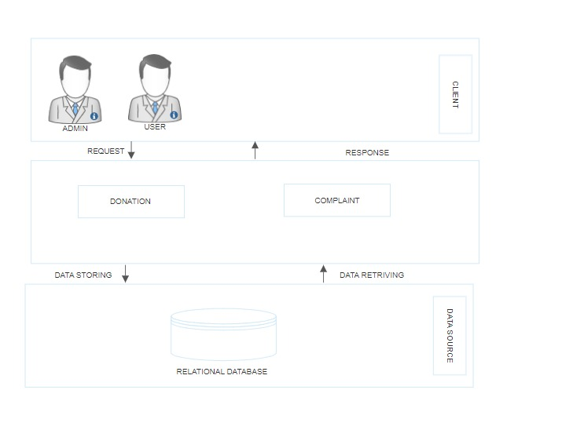

**DATA FLOW DIAGRAM**

**LEVEL 0**

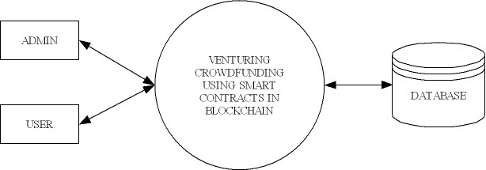

**LEVEL 1**

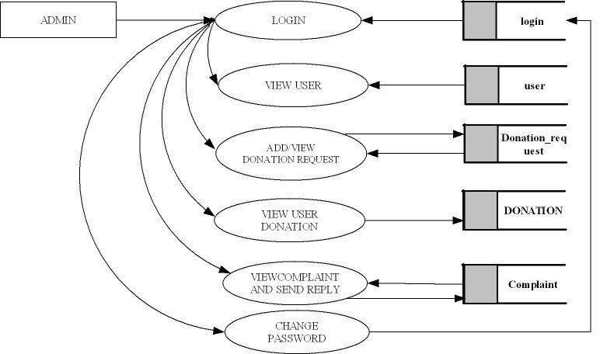



**LEVEL 2**

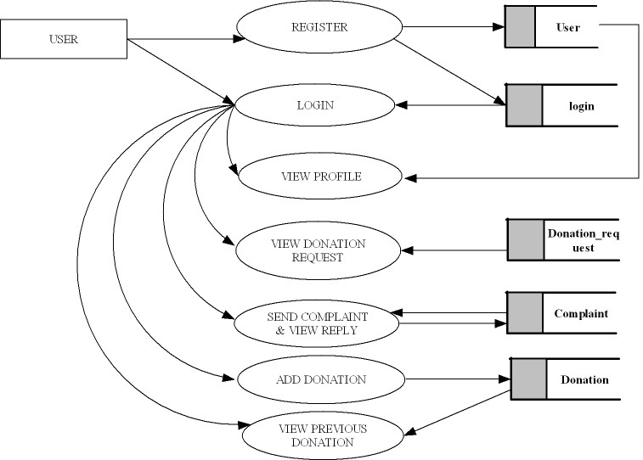

**ER DIAGRAM**

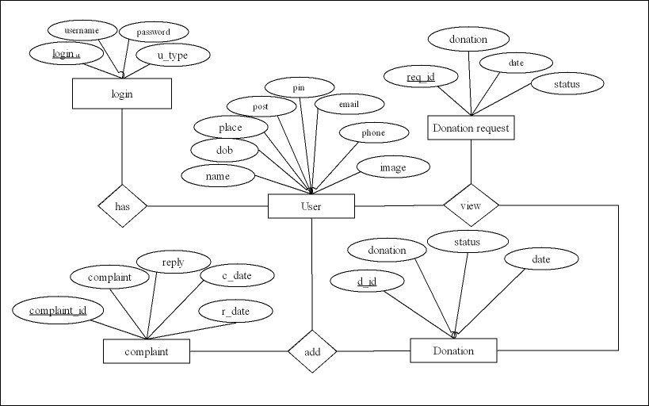

**PROJECT PLAN**

|  |  |  |  |  |  |
| --- | --- | --- | --- | --- | --- |
|  | Week 1 | Week 2 | Week 3 | Week 4 | Week 5 |
| Backend |  |  |  |  |  |
| Front end |  |  |  |  |  |
| Coding |  |  |  |  |  |
| Designing |  |  |  |  |  |
| Validation |  |  |  |  |  |

.

**HARDWARE AND SOFTWARE REQUIREMENT**

**Hardware Requirements**

* + Input Device : Mouse, Keyboard
  + Output Device : Monitor
  + Memory : 4 Gb Ram(Minimum)
  + Processor : Intel core i3 or above

**Software Requirements**

* + Operating System : Windows 8 /10for Better Performance
  + Front End : Python (Flask)
  + Back End : Mysql
  + Software Used : Pycharm
  + Web Browser :Internet Explorer/Google Chrome/Firefox(for web application)

**CONCLUSION**

it is concluded that the crowdfunding using blockchain is a relatively new concept to the ICT community. With the evolution of blockchain, our proposed work have a bright future and a large scope for improvement and evolution. In the future, the proposed research work can progress further in an easier and safer way for all ideas that are achieved through the proposed crowdfunding application